This is the github repository where the libraries and example code can be found, ESP Modules are explained here:

<https://github.com/esp8266/Arduino/blob/209c87715768b0f280bb85b3832883487dc4d2e9/doc/boards.md#generic-esp8266-modules>

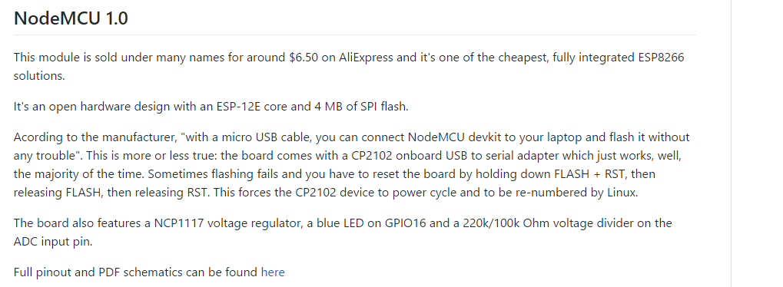

See pinout and other stuff about the NodeMCU 1.0 here:

<https://github.com/nodemcu/nodemcu-devkit-v1.0>

Library Setup - <https://github.com/esp8266/Arduino>

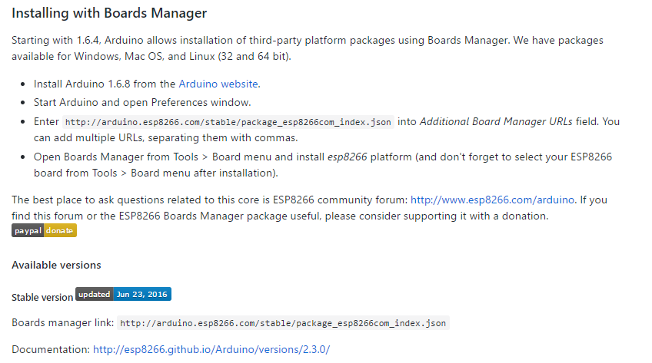

* Clone github: <https://github.com/esp8266/Arduino>

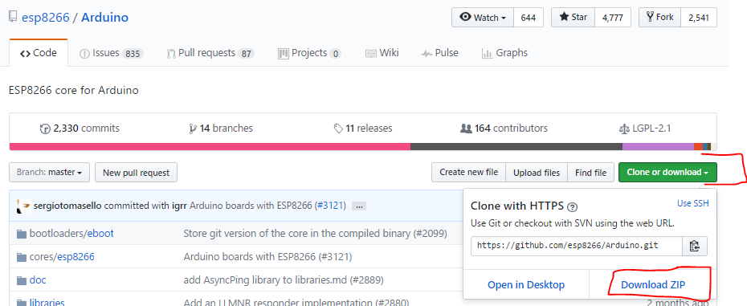

* Go unzip the file!
* Go to folder “\Arduino-master\Arduino-master\libraries\” and copy and zip the folder “ESP8266WiFi” to your preferred location
* Add the zipped library in the Arduino IDE:

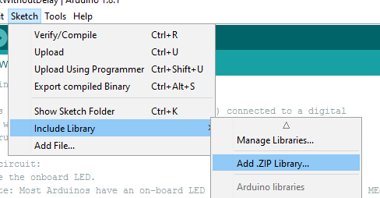

Upload a sketch

1. Open file e.g. “WiFiAccessPoint_v0.1” from <https://github.com/arsalansabet/Gas-Sensor/tree/master/Code/Test%20Code>
   1. And select the NodeMCU 1.0… as your board
   2. Make sure the programmer is “AVRISP mkII”
   3. Open the serial monitor to see printin statements from the ESP
   4. Select the proper port, this will vary from PC to PC. Ports are shown as “COMx”

